Grant Access to Facebook Business Manager
Last Updated / Reviewed: August 26th, 2021
Execution Time: ~10 mins

Goal: To grant Facebook Business Manager access to agency, contractor, or employees so they can help manage your Facebook page or ads.
Ideal Outcome: Your agency, contractor, or employees will have access (but not ownership) to your Facebook Business Manager account.
Pre-requisites or requirements:
- You need a Business Manager Account;
  - If you don’t have one yet (or have not heard of Facebook Business Manager) you can follow the “Create a Business Manager Account” chapter of SOP 010;
- This guide will also need your Facebook Page and Ads Manager to be managed by a Facebook Business Manager account, NOT from a personal account. If you haven’t done so, please refer to the following SOP:
  - Migrate Facebook Assets from personal to Facebook Business Manager

Why this is important: If your assets aren’t properly accounted for and managed, you can easily lose track who has access to what.
Where this is done: Inside Facebook Business Manager.
When this is done: Every time you start to work with somebody else on a Facebook Asset.
Who does this: Business owner who has admin access to Facebook Business Manager.

Migrating Facebook Page and Ads Manager from a personal account to Business Manager

If your Facebook Page and Ads Manager are NOT currently being managed with Facebook Business Manager, you will need to complete this step. If you’ve already done this, you can click here to skip to the next step.

We recommend to always use Facebook Business Manager to manage your Facebook assets regardless of whether you’re an agency managing campaigns for clients or company granting access to employees or agencies.

- If you don’t have a Business Manager account yet, you can follow the “Create a Business Manager Account” chapter of SOP 010.

This chapter of the SOP will walk you through the steps to claim access to assets that were outside of Business Manager (i.e. with a personal Facebook account).

Important: Claiming Facebook Page and Ads Manager should only be performed if you are the actual owner (with admin access). If you are an agency, freelancer, or employee working on another company/person’s assets (Pages, Ad Accounts, etc) do not claim those assets. Instead, you can simply be assigned the role that you need by following the next chapters of this SOP.

- Access required: Admin

- Typical scenario: In the early stages of your business, you or an employee created an Ad Account or a Facebook Page using their own personal profile. Your business should now use Business Manager to manage your assets. This will also allow you to easily control grant and revoke access to your assets to your employees or when working with freelancers, agencies, or consultants.

- Who performs this action: The Admin of the Business Manager account who wants to claim the assets. (This could be the business owner, a CEO, or other stable member of the organization)

- Migrating Facebook Page to your Business Manager:

- Log in to your Business Manager Settings here
- On the sidebar click “Pages” → “Add” → “Add a Page”

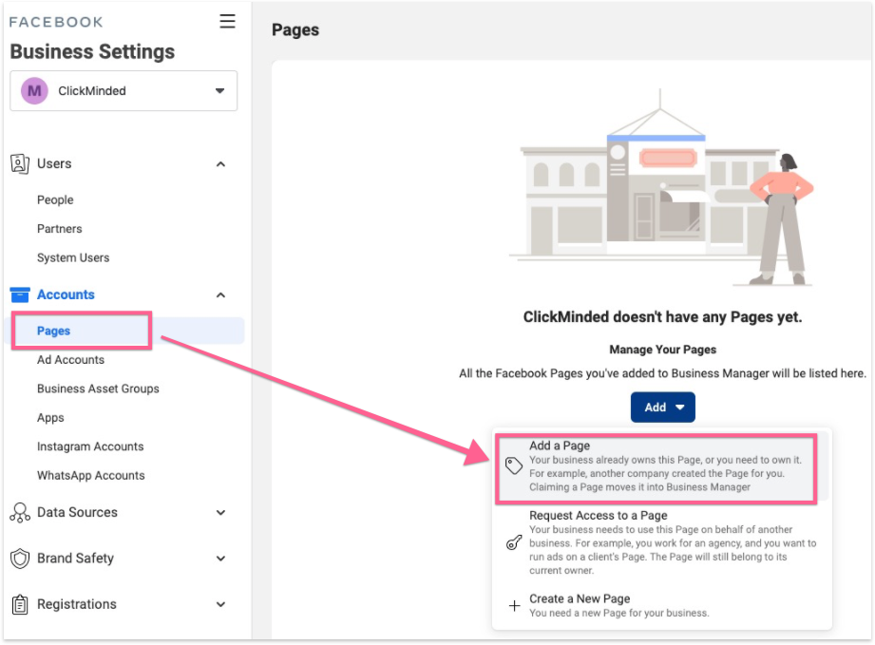

- Search for your Page’s name, or alternatively paste your page URL → Click “Add Page”:
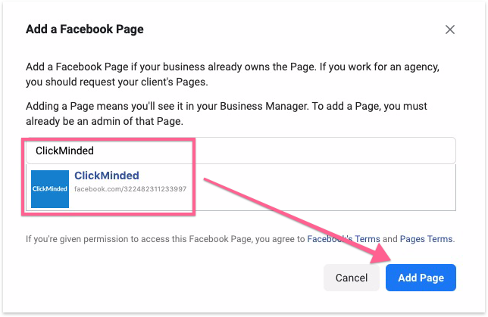

- That’s it! You’ve added your page to your Business Manager. If you were already an Admin of the page your request will be approved immediately and you will be added as a Page Admin for that page inside your Business Manager.

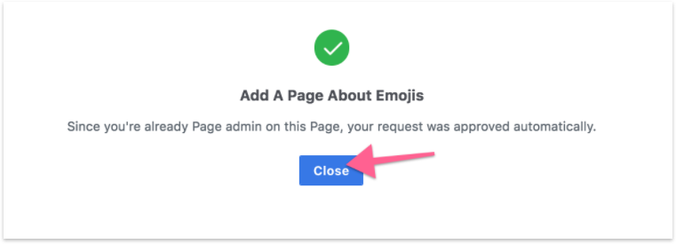

- Migrating Ad Accounts to your Business Manager:

- Log in to your Business Manager here.

- On the sidebar click “Ad Accounts” → “Add” → “Add an Ad Account”.

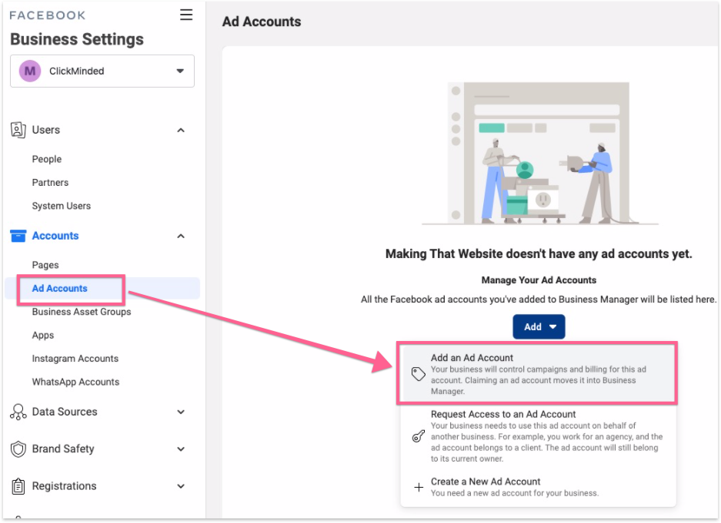

- You’ll find a field prompting you to enter your “Ad account ID”, you can find your Ad Account ID by opening “Ads Manager” and clicking on the top-left dropdown. Copy that Ad Account ID over to that field, when you’re done click “Add Ad Account”:
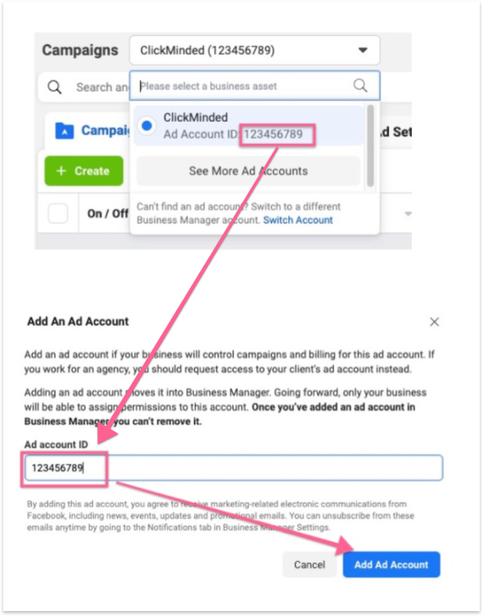

- That’s it, you’ve claimed your Ad Account and if you were an Admin before, you now have Admin access to that Ad Account as well.

Use the links below to jump to the section of this SOP that fits your needs

- I’m the owner of the assets and want to assign them to a third party:
  - My freelancer or agency told me they’re using Business Manager as well: Assigning Facebook Business Manager access to Agency

  - My freelancer or agency told me they’re not using Business Manager:
    - It’s the first time you’re working with them: Granting Facebook Business Manager to a personal account;

- I’m the owner of the assets and want to assign them to an employee:
    - It’s the first time you’re working with that employee: Granting Facebook Business Manager to a personal account

Granting Facebook Business Manager access to an agency or contractor

Note: Granting Facebook Business Manager access to a third party agency does NOT transfer ownership to them. This step only gives them permissions to help you manage Pages or ads.

  - Access required: Multiple

  - Typical scenario: An agency starts working with a client for the first time and needs access to (client’s) Facebook Business Manager account.

  - Who performs this action: The client.

  - Inputs needed: Your agency or contractor should provide you their Facebook Business ID .

- Head to your Business Manager settings here.
- Click “Partners” → “Add” under Partner to share assets with.

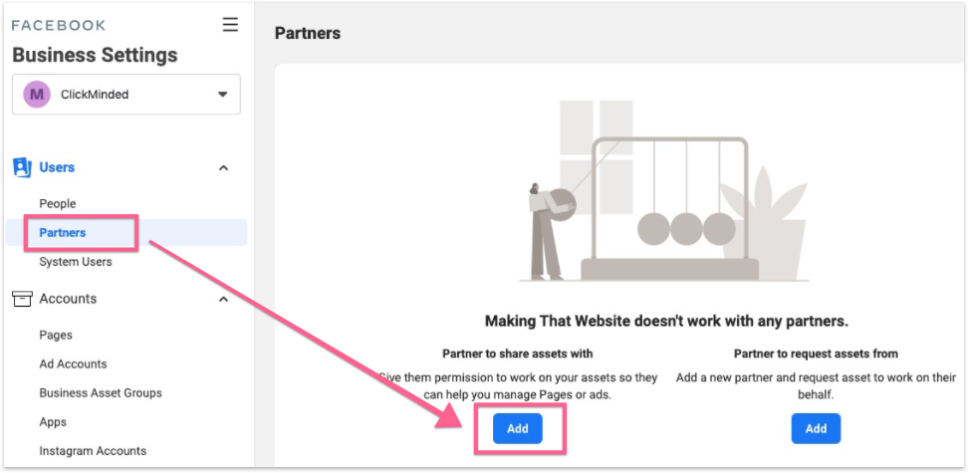

- Enter your partner’s Business ID (your partner needs to provide you with this) → “Next”;

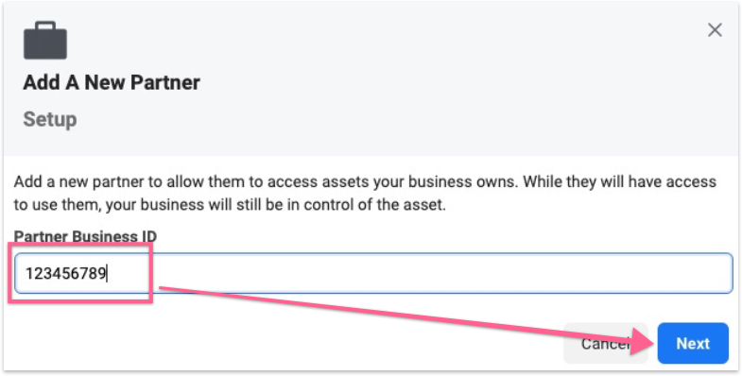
- Select all the Assets that you would like to share with your partner, their roles (access-levels), and when you’re done, click “Assign Assets”:

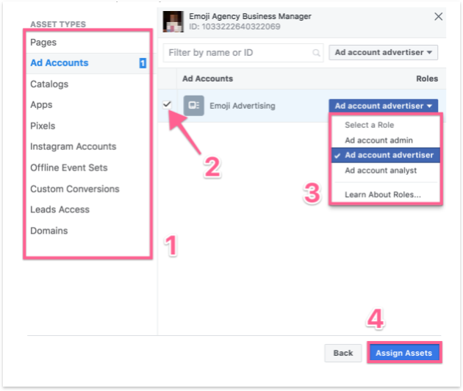

- That’s it! You’ve successfully given access to your assets to your partner’s Business Manager, he is now able to also assign the same permissions that you’ve set to other members of his team.
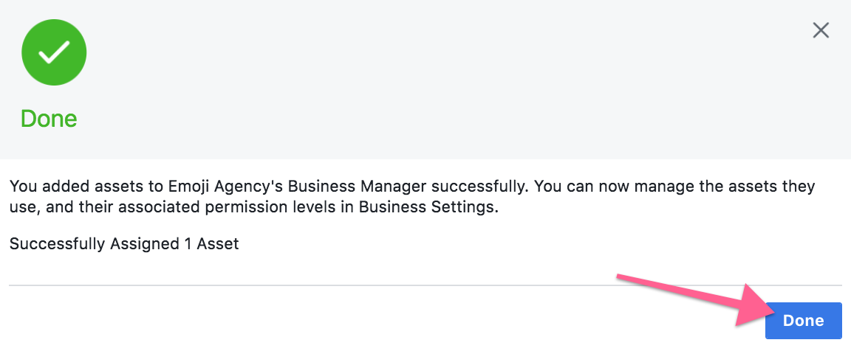

Granting Business Manager access to a personal account

Access required: Admin

  - Typical scenario: An agency assigns ad accounts and pages to their employees, so they can work on them. A business owner / team leader assigns ad accounts to a member of his team.

  - Who performs this action: Business owner or account manager who wants to share access to their Business Manager’s assets.

- Head to your Business Manager settings here;

- On the sidebar, click “People” → “Add”

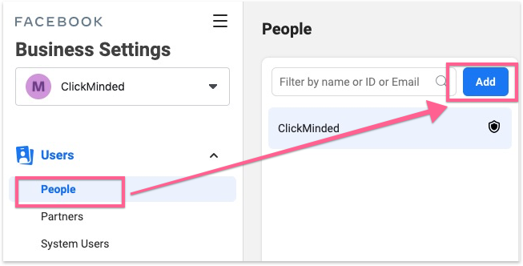

- Enter the email address of the person that you want to give access to (ideally their work email, it doesn’t need to be the email associated with their personal Facebook account), make sure you are assigning the right roles, and click “Next”;

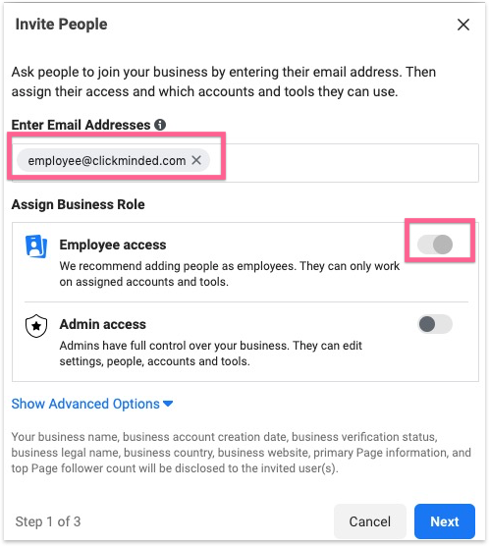

- Select all the Assets that you would like to share with your partner, their roles (access-levels), and when you’re done, click “Assign Assets”:

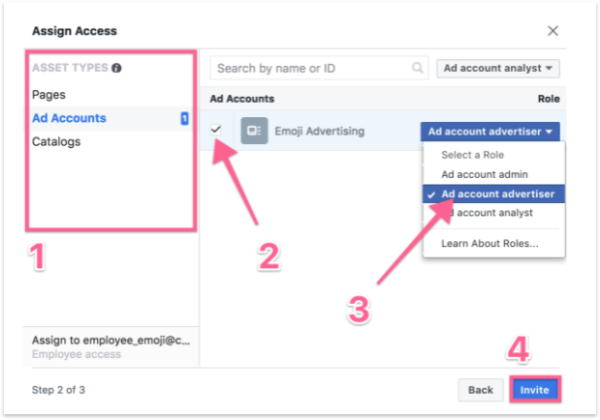
- That’s it! Your employee will receive a confirmation email that they can use to connect their own account. You might want to send your employee the instructions below.

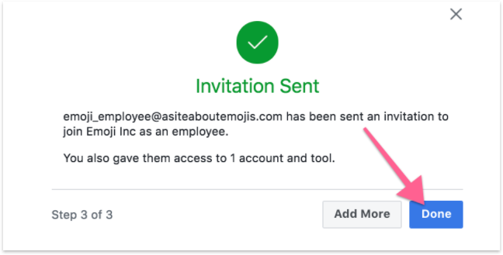

- Employee’s Instructions:
- Your employee, will receive an email containing the confirmation link, a few minutes after you’ve sent the invite:

- Open the email → Click “Get Started”

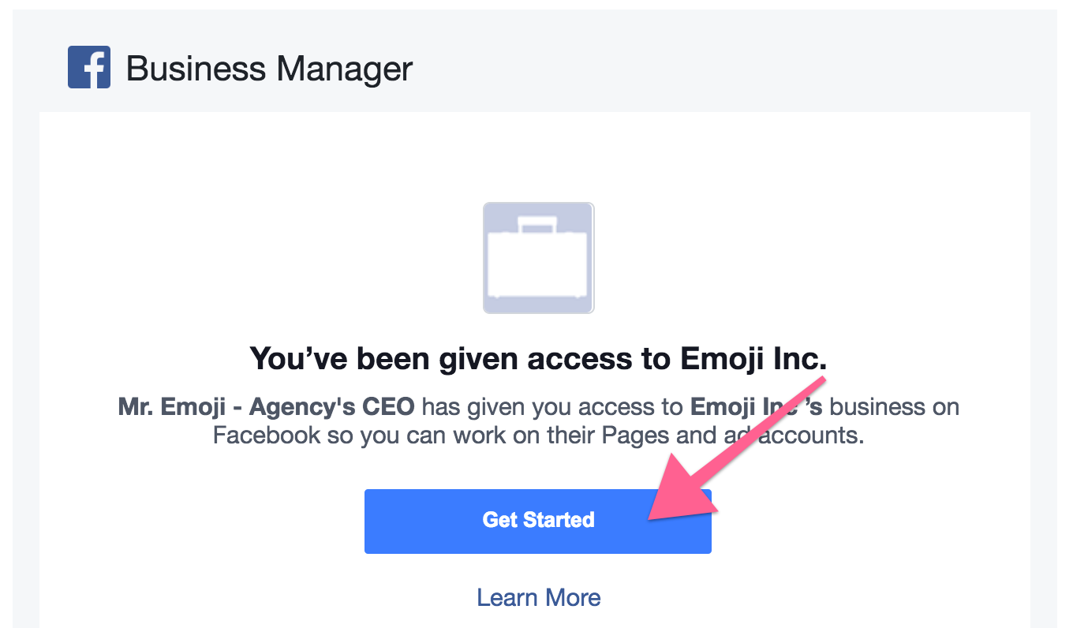

- Add your name and click “Continue”
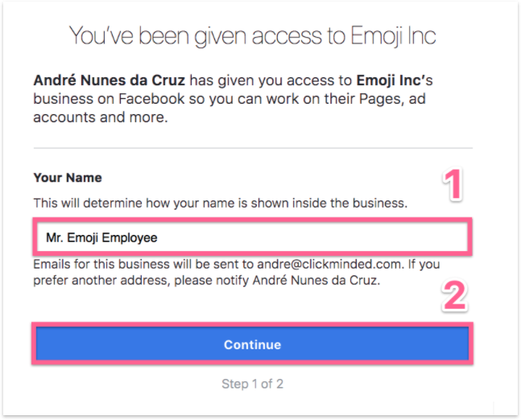
- Login to the personal Facebook account, and that’s it, that Business Manager account and its assets are now being shared!

